ITA0388-MOBILE COMPUTING FOR 5G

LAB PROGRAMS

1 Use Figma to create an interactive diagram illustrating the components of a basic cellular system.
Link ::::https://www.figma.com/design/QlEa2nvVYpANOHgDduSvtB/Untitled?node-id=0-1&t=l8zKQRWk046Jx5q9-1
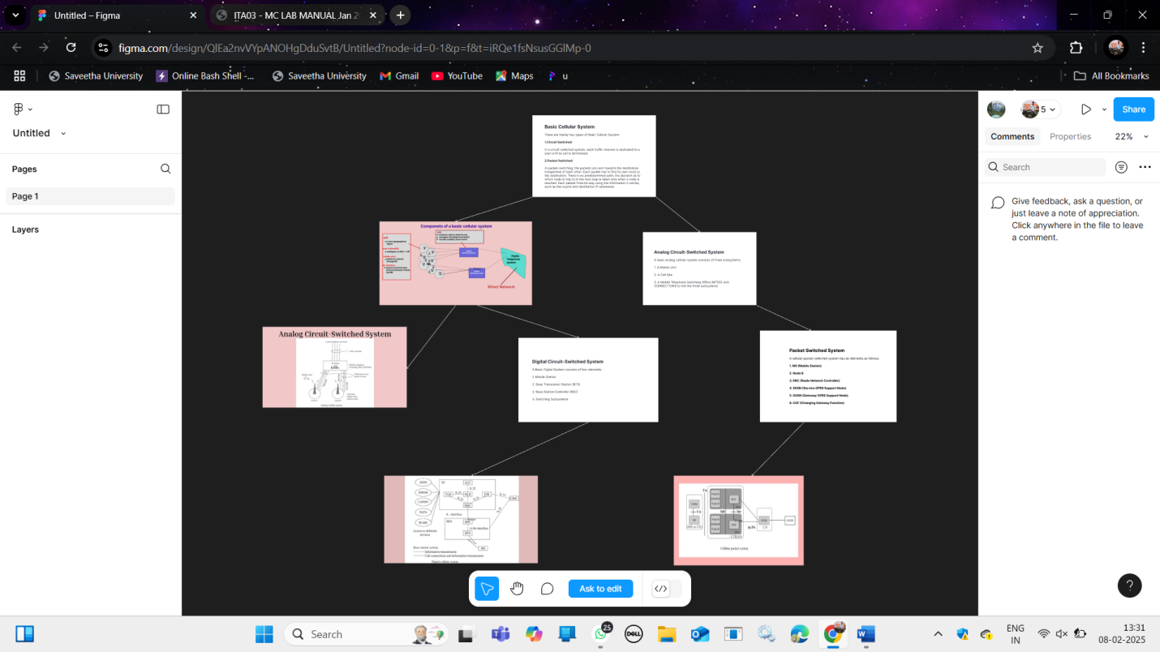

2 Design a user interface prototype for a mobile station using Figma, considering connectivity and convenience.
Link ::: https://www.figma.com/design/q8zKHf0RPqIXj5vt3ABQsa/Bus_station_app?node-id=0-1&t=xnEd2AZYPIcWN494-1
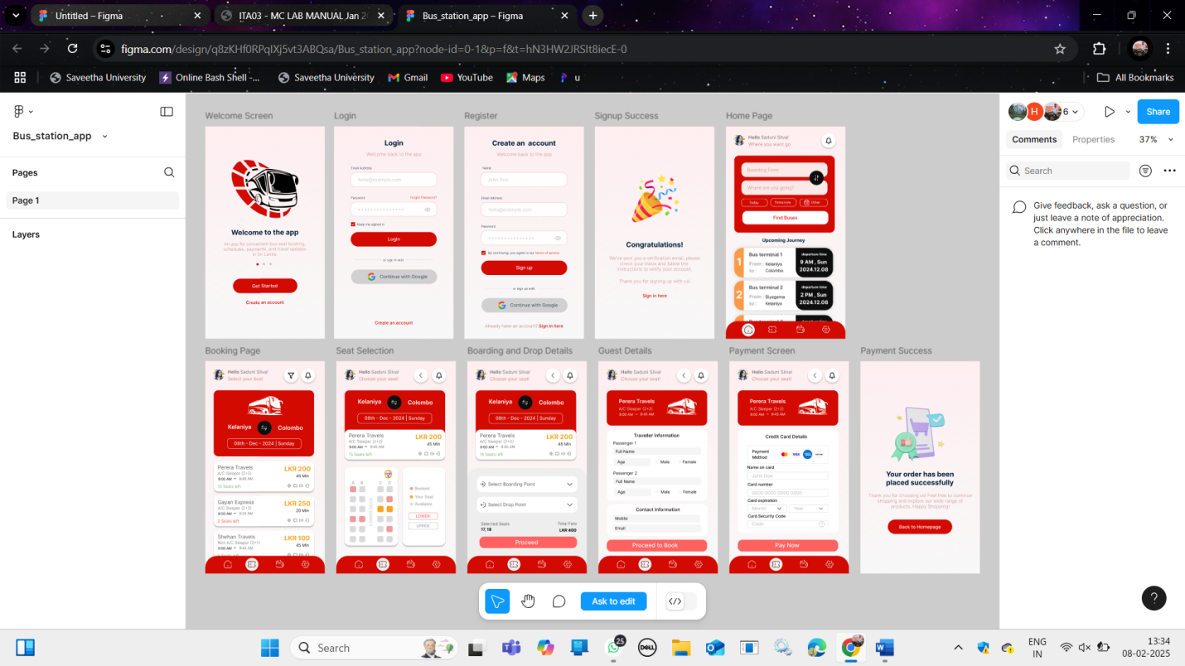

3 Develop a flowchart in Figma depicting the operation of a Network Switching Subsystem in a mobile cellular system.
Link :: https://www.figma.com/design/37E1651Si0DREHtJloJfpP/network?node-id=0-1&p=f&t=YNlzd0GVBrffMqHp-0
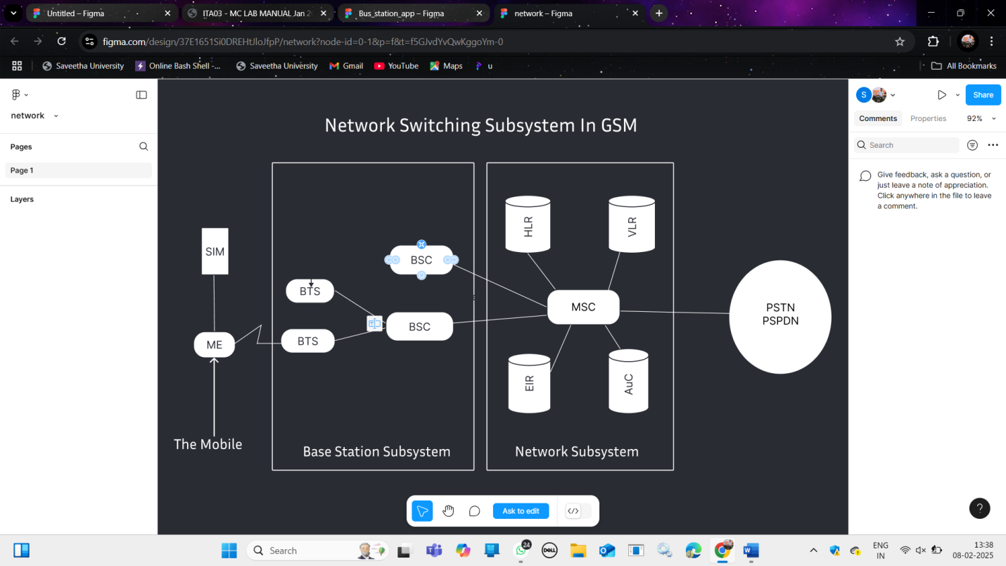

4 Create a visual representation in Figma highlighting the key elements of mobile network protocol stacks.
Link ::: https://www.figma.com/design/JnExzfiAeFjZGuoDe8P48h/4th.Mobile_network?node-id=0-1&t=X6WwkQYoAtUywPAD-1
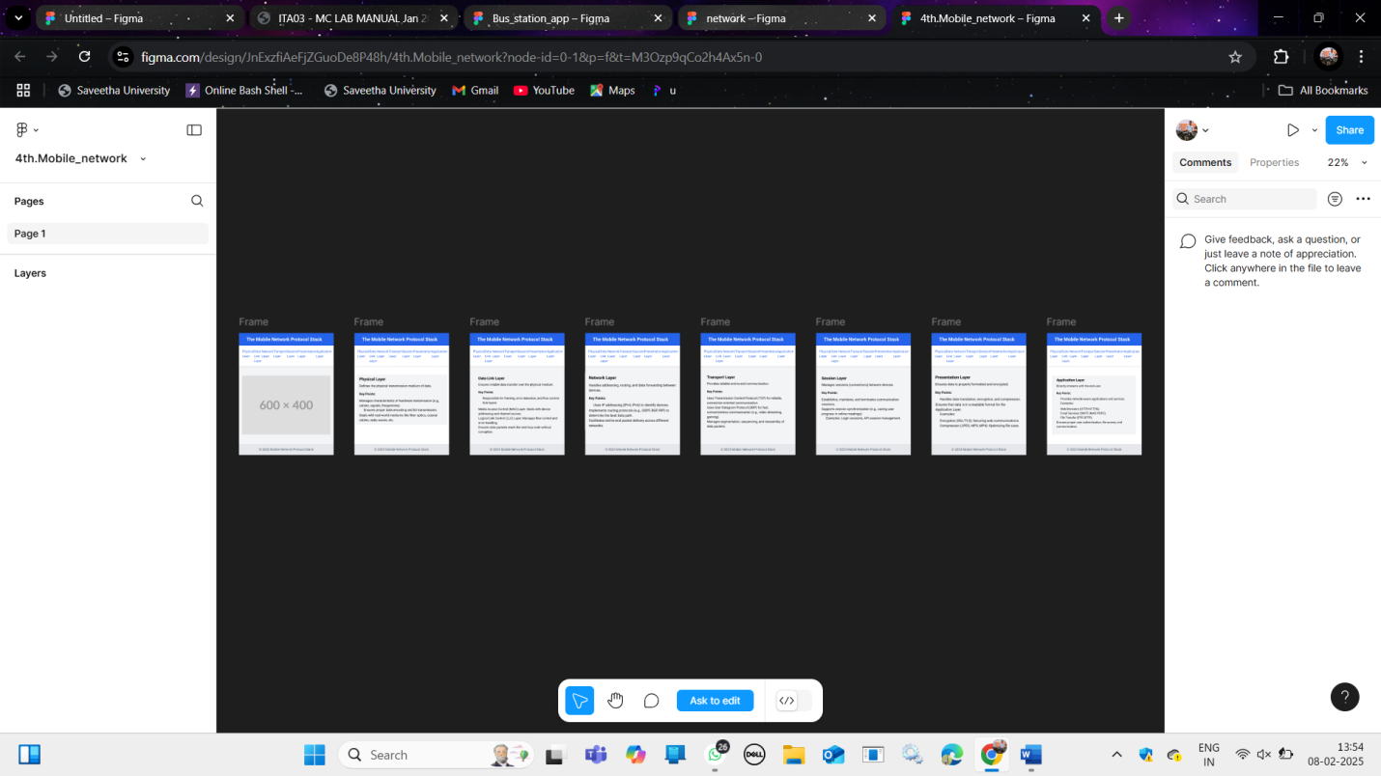

5 Design a wireframe for a mobile application that incorporates localization features using Figma.
Link ::: https://www.figma.com/design/ObTfhnjvtDGTo9t8Vf032w/Untitled?node-id=0-1&t=V0MDrnrRlbjYXQga-1
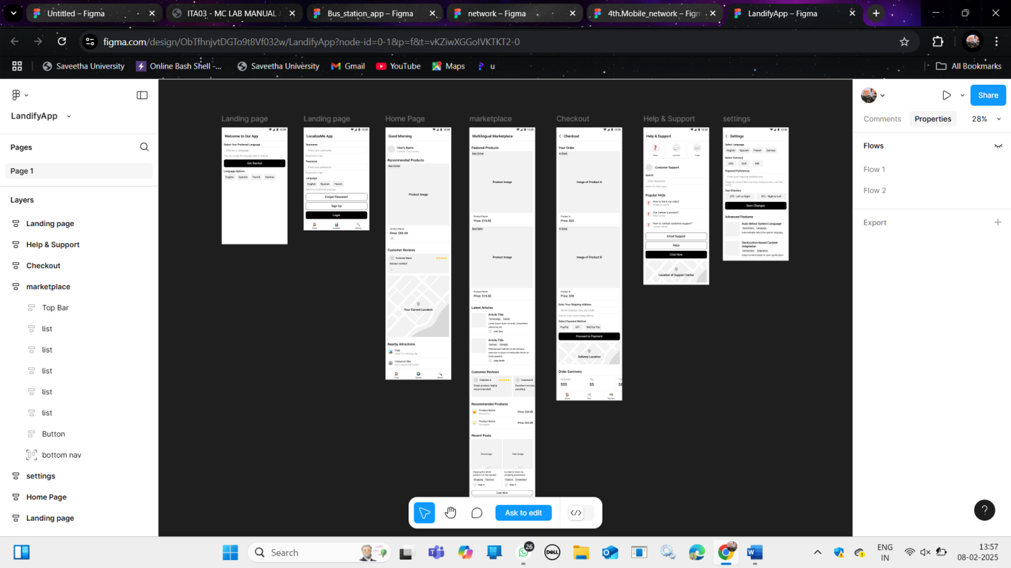

6 Use Figma to simulate a handoff scenario in a mobile network and visualize the process.
Link ::: https://www.figma.com/design/37E1651Si0DREHtJloJfpP/network?node-id=0-1&p=f&t=YNlzd0GVBrffMqHp-0

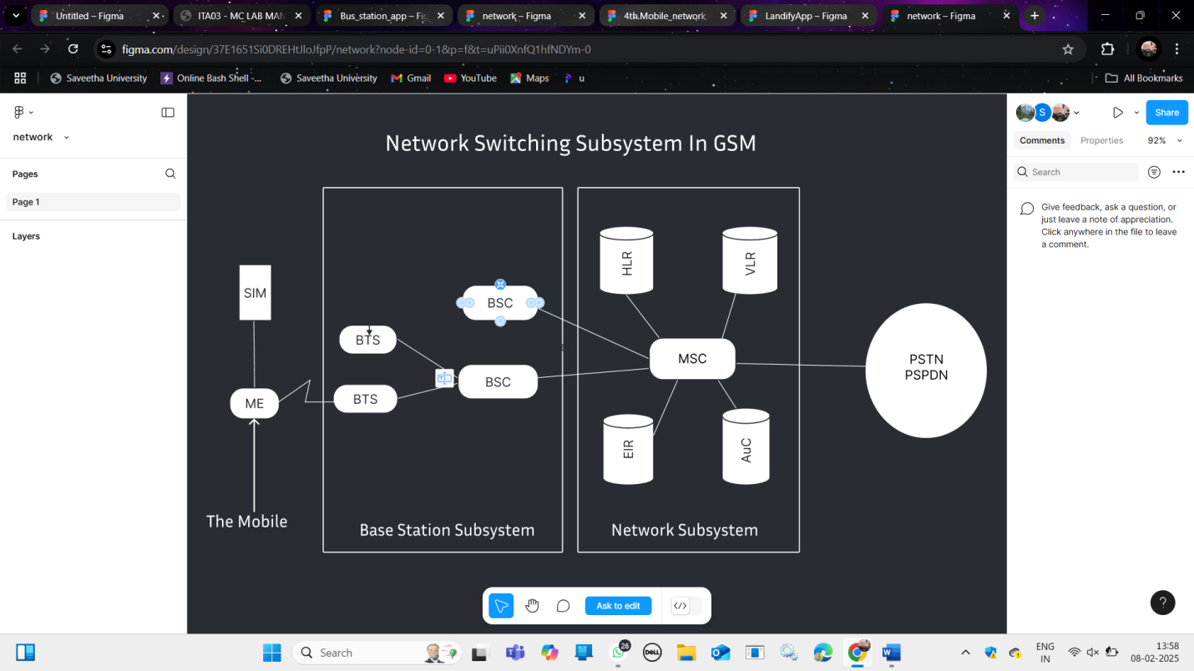

7 Develop a dashboard prototype in Figma displaying performance criteria for a cellular system.
Link ::: https://www.figma.com/design/wa1hvNTgPD75qy8RrvZ5oa/Dashboard?node-id=0-1&p=f&t=rMz4m4uIvmcPBqNg-0
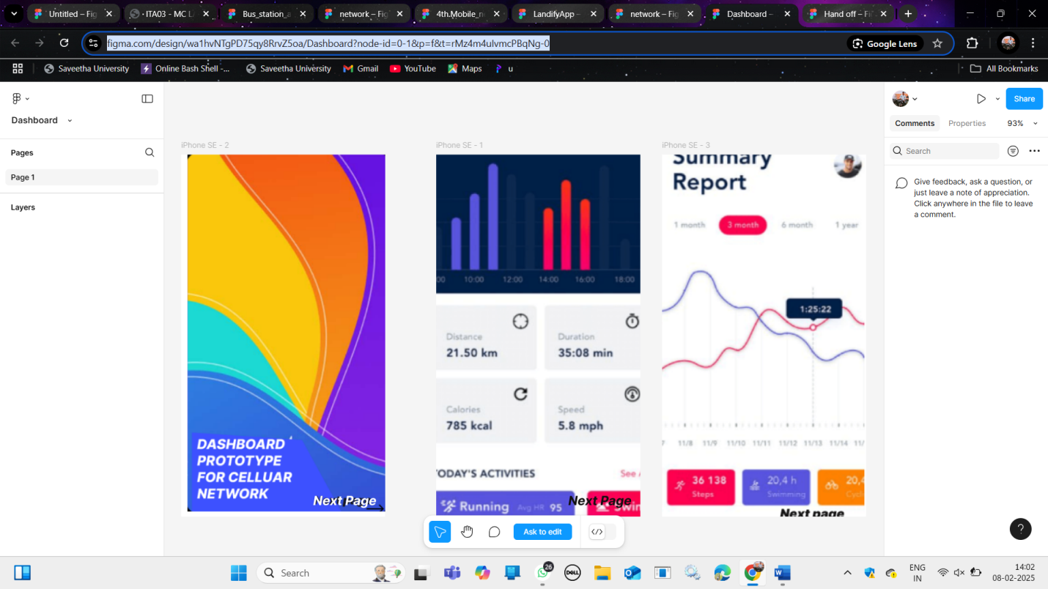

8 Create an infographic in Figma explaining the concept of Public Land Mobile Network (PLMN).
Link :: https://www.figma.com/design/fsRjTv027yQ46RqGd3BgiX/Hand-off?node-id=0-1&p=f&t=qcXA8z6pGynx81vg-0
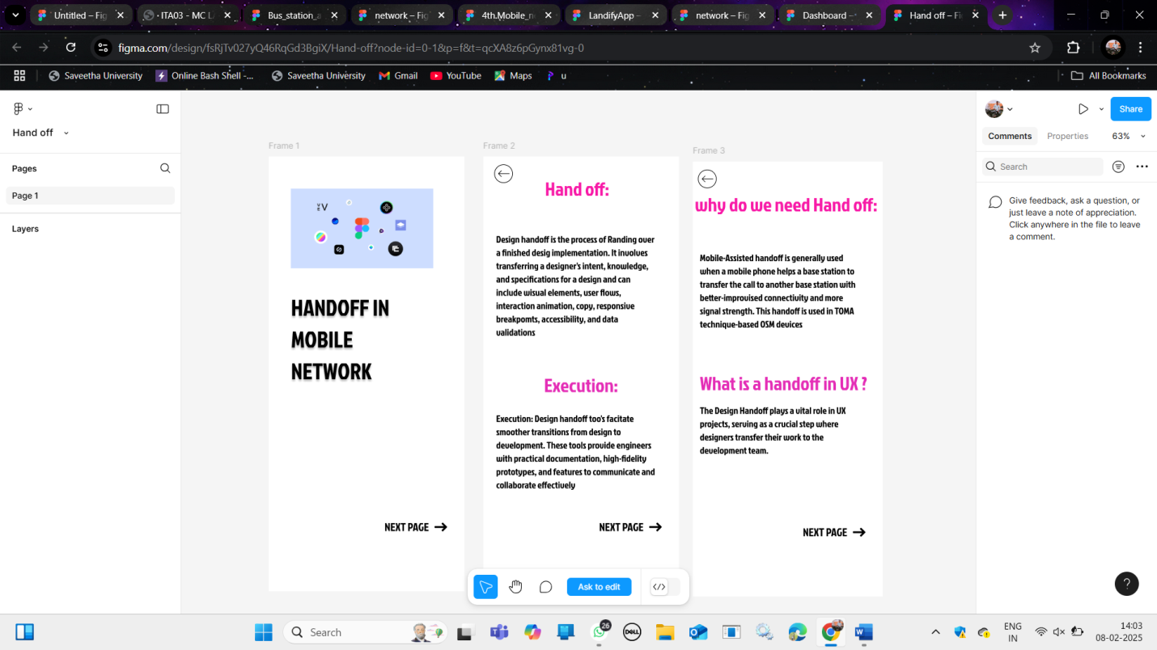

9 Develop a user interface prototype for a GSM service using Figma.
Link ::: https://www.figma.com/design/wZO54GKxV5RnA59ZfV1hNN/Untitled?node-id=0-1&t=LgZcvVnVAmGKK91y-1
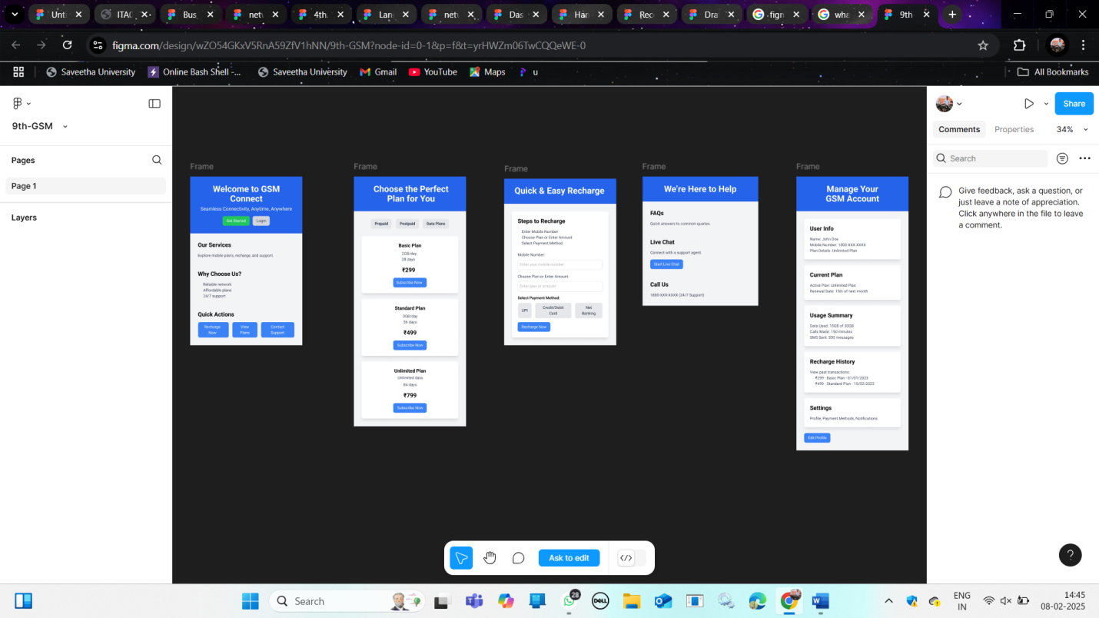

10 Design a wireframe for a mobile application that incorporates security measures using Figma.
Link ::: https://www.figma.com/design/FrfFS3THFV2rGR70I271uS/10th-access_tech?node-id=0-1&t=TV29OwNUD10oE5vg-1
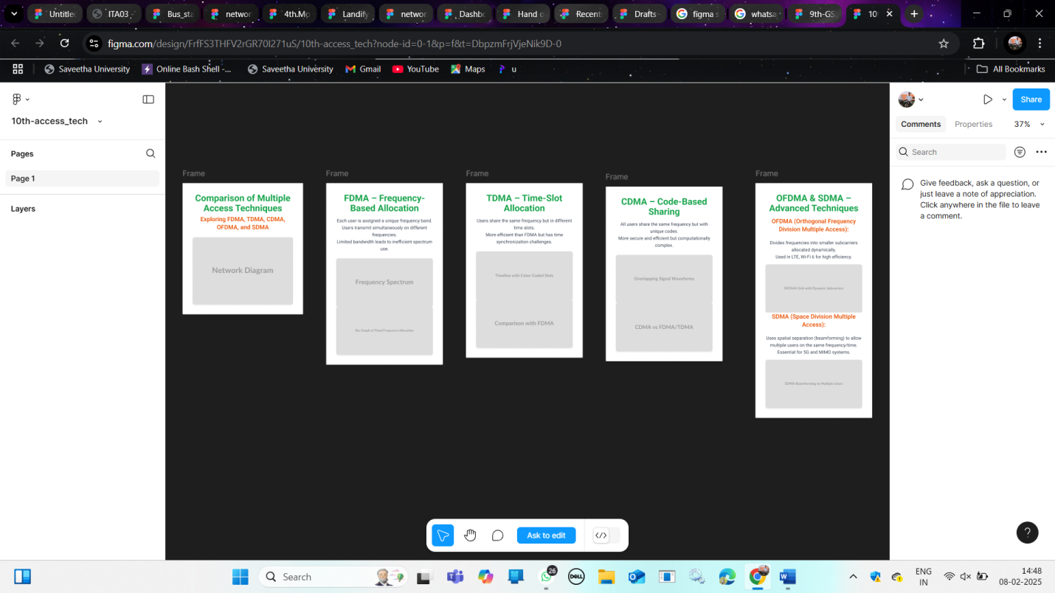

11 Design a wireframe for a mobile application that incorporates security measures using Figma.
Link ::: https://www.figma.com/design/FFJDUmADehuvFXkXcPao16/11th-Security_app_online_bunny?node-id=0-1&p=f&t=teIlxOSqaS8YSMyx-0
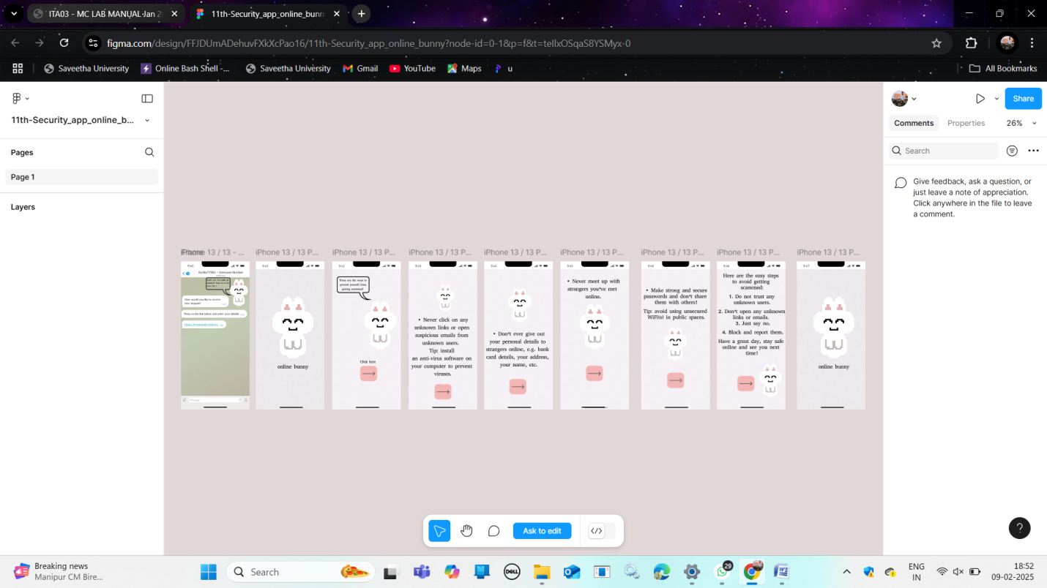

12 Use Figma to create an interactive diagram illustrating the evolution from 1G to 5G.
Link ::: https://www.figma.com/design/lRZpPSkHcivgiTp4vdtpnr/12?t=4sDk7w38iPvMVKTi-1
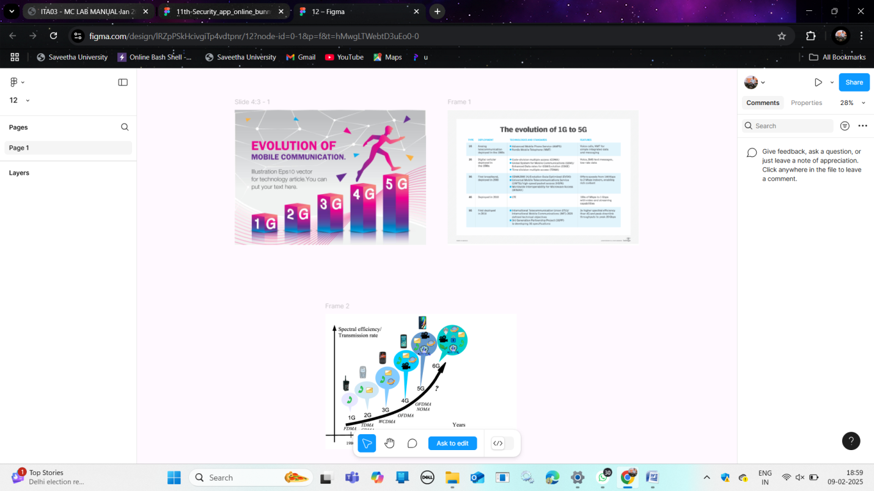

13 Design an infographic in Figma comparing mobile communication and mobile computing
Link ::: https://www.figma.com/design/vj4YKzL9xi2hVcJHFgPSBE/13?node-id=0-1&p=f&t=U1lS0X4PmBJQFSye-0
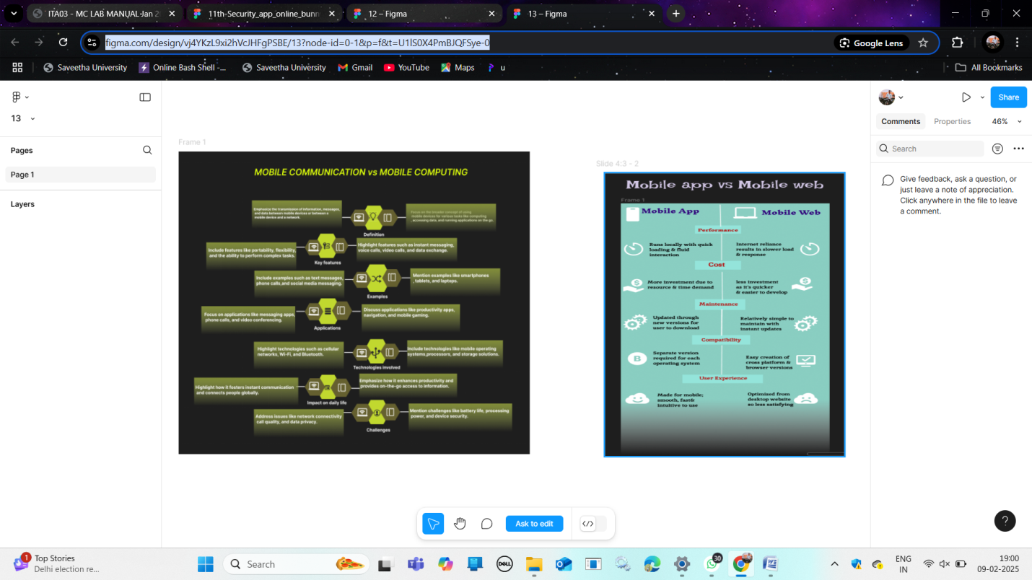

14 Develop a flowchart in Figma explaining the operation of General Packet Radio Service (GPRS).
Link ::: https://www.figma.com/design/gxFc79KzUMJq3fLM1scbAY/14-flowchart?node-id=0-1&p=f&t=5g3j5sHhytPvReZT-0
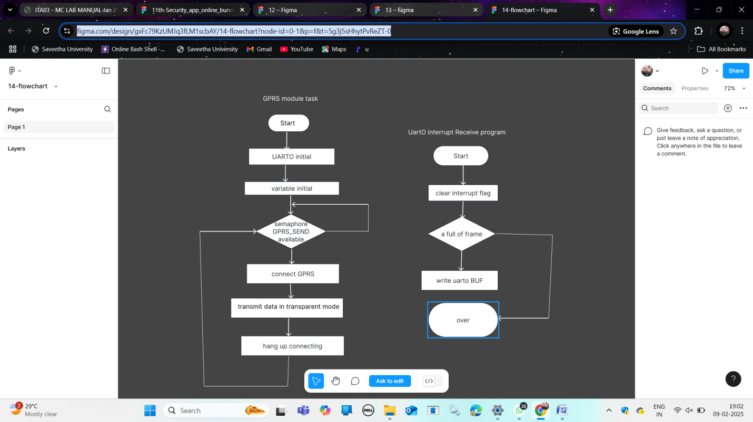

15 Design an interactive presentation in Figma explaining the issues in mobile IP.
Link ::: https://www.figma.com/design/BJNGhKT2EfptUOKDXMi0j5/15?node-id=2-53&t=5EuBxz6QpeD1qGbQ-0
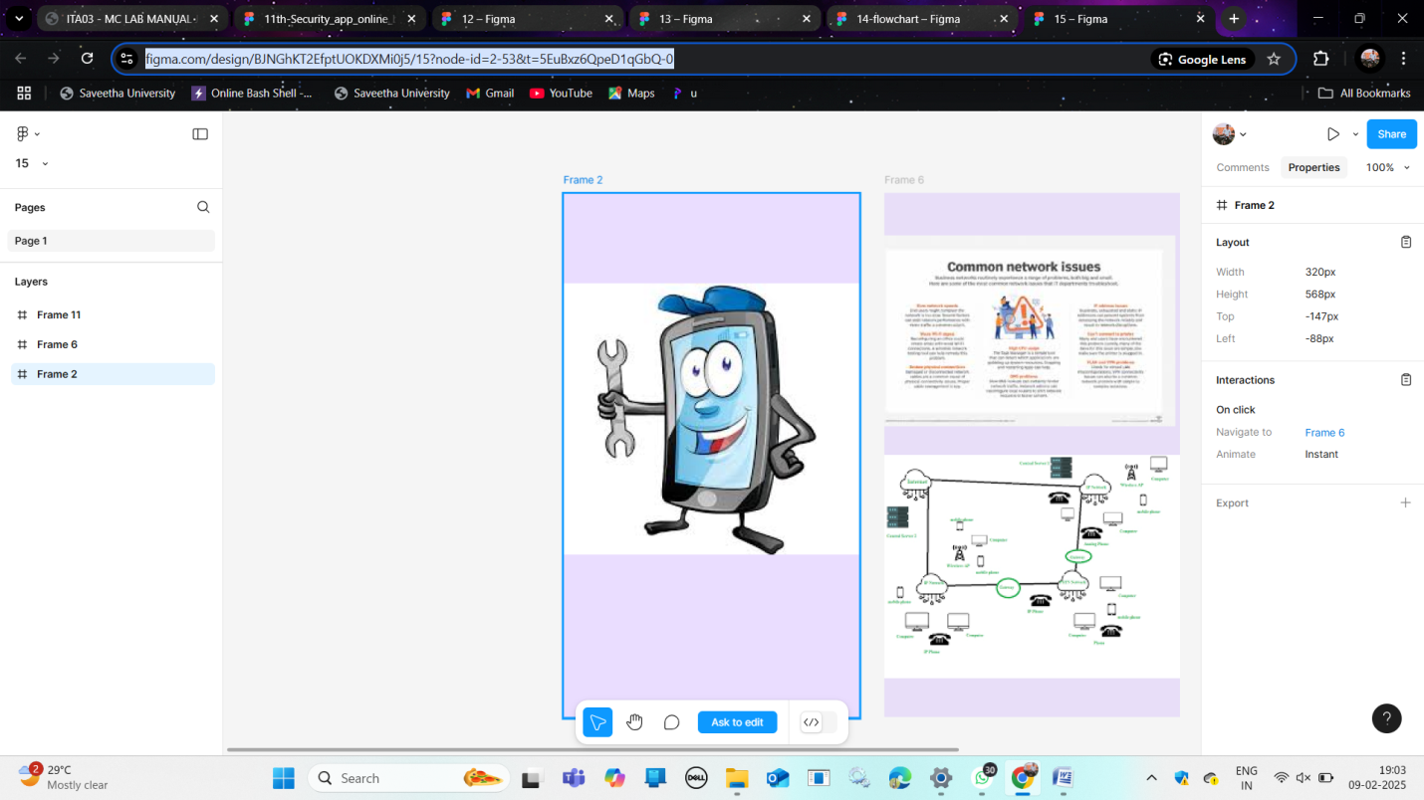

16 Develop a wireframe for a mobile application that addresses challenges related to ad hoc wireless networks using Figma.
Link ::: https://www.figma.com/design/Ecp3Lk4GjRIcCaGnpktdsA/16?node-id=1-25&t=bX0HUO4oSjkrBHKK-0
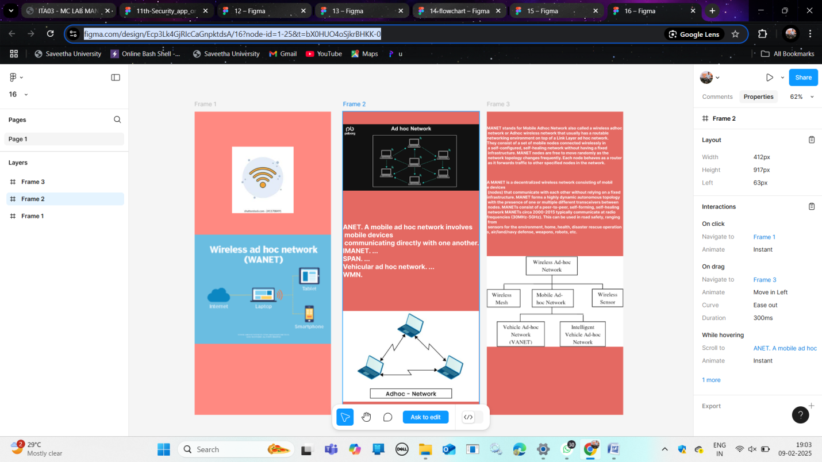

17 Create a visual representation in Figma illustrating the operation of proactive and reactive routing protocols in mobile IP.
Link :: https://www.figma.com/design/h67PXCDqovfZJBV2jNS5nN/17?node-id=0-1&p=f&t=nAraeGMR9t0YqIox-0
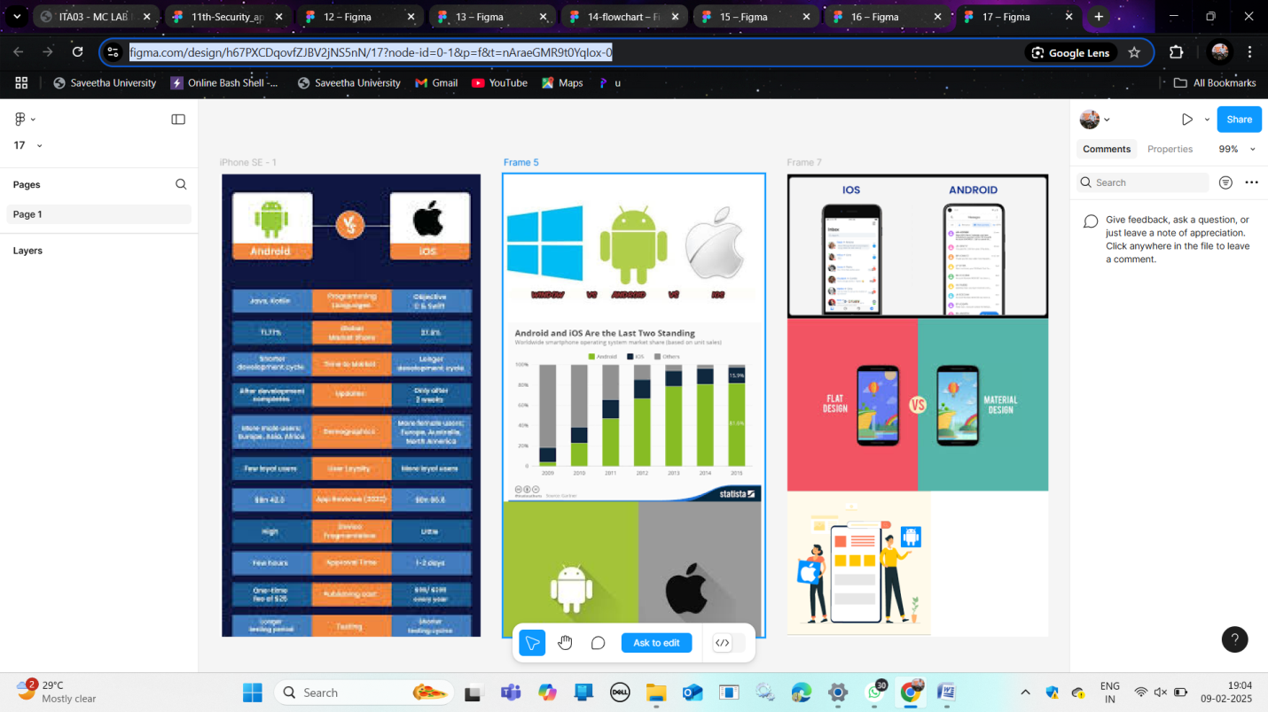

18 Use Figma to create an infographic comparing and contrasting the architectures of Android, iOS, and Windows.
Link ::: https://www.figma.com/design/y2Ja5XTeeo4z51TnPM6tdn/18?node-id=2-39&t=0ejIcNn7i9F8NRdF-0
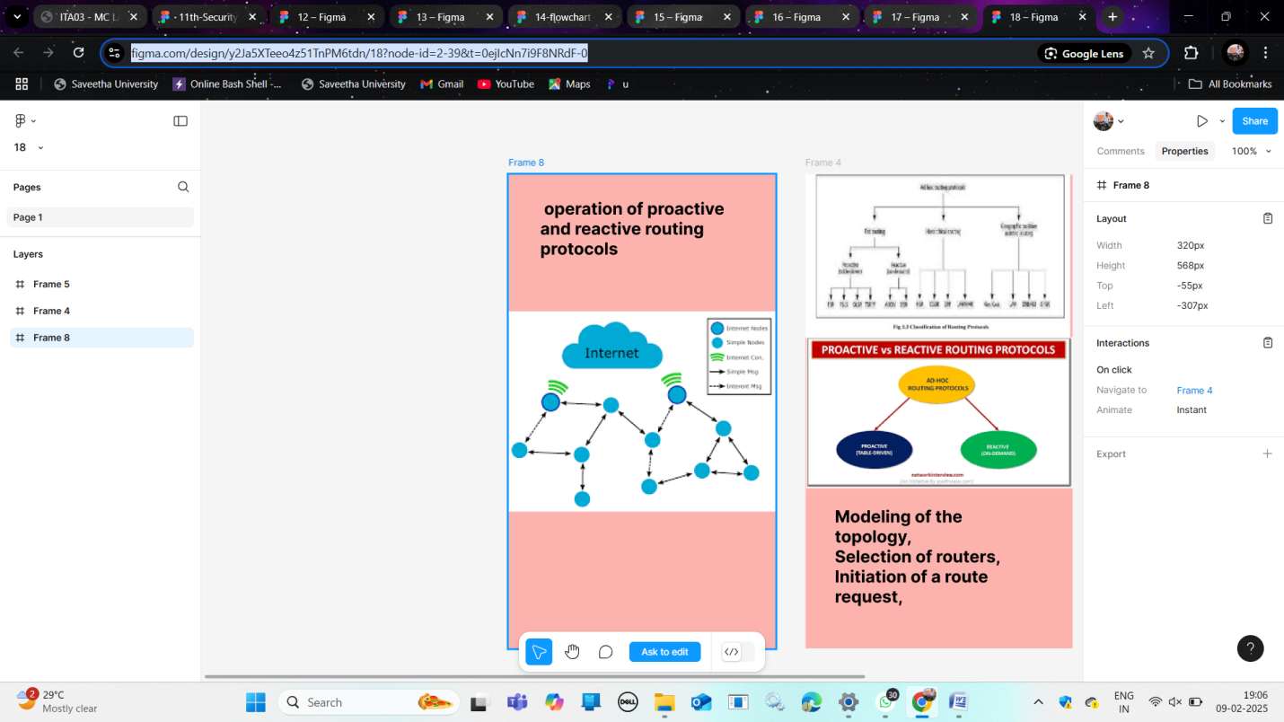

19 Develop a user interface prototype for an Android application using Figma.
Link :::: https://www.figma.com/design/f2XVGhGPCjSjZYsjAjNyEV/19?node-id=0-1&p=f&t=IHXYbIfvtI7GXikg-0
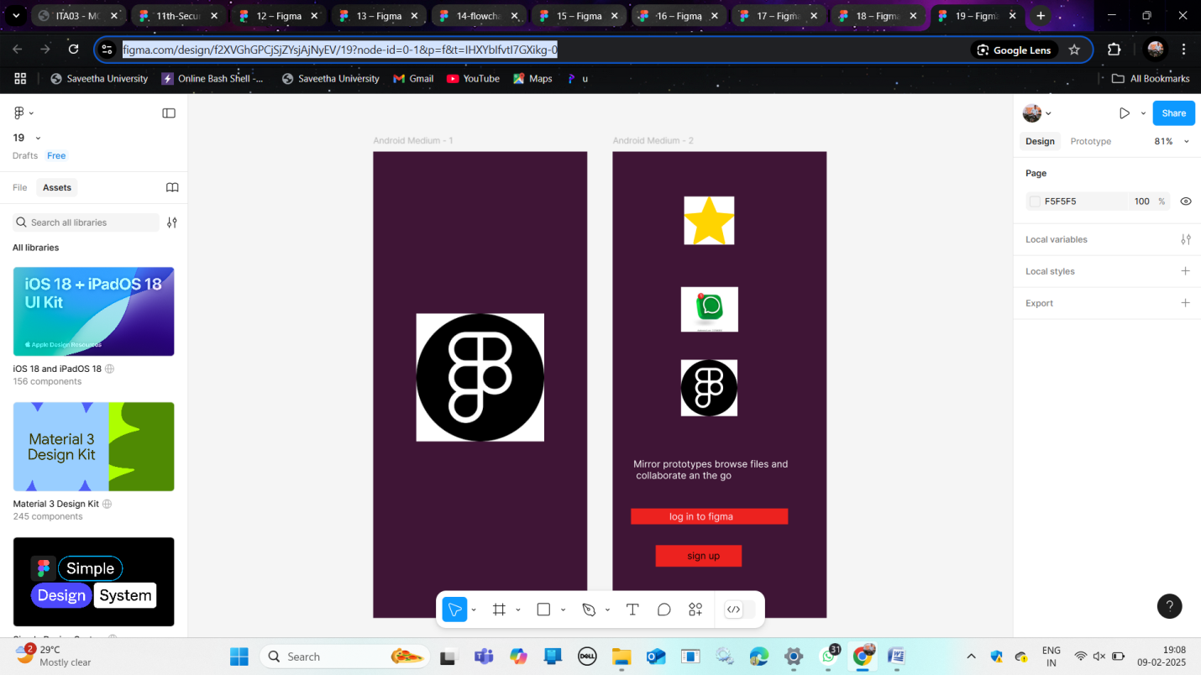

21 In Figma, design a mobile app interface that prioritizes user connectivity and convenience. Highlight key elements.
Link ::: https://www.figma.com/design/OctewCKvG13TblDSi2MWXT/Food-app-design?node-id=0-1&t=GQJTcRs2dn5bWZXq-1

22 Create wireframes illustrating how localization features can be integrated into a mobile app, ensuring a user-friendly design in Figma
Link ::: https://www.figma.com/design/ZII7KsLuFXadzDfNlIstRR/22?node-id=4-1389&t=TuLMIbWJnP4LGxeA-1
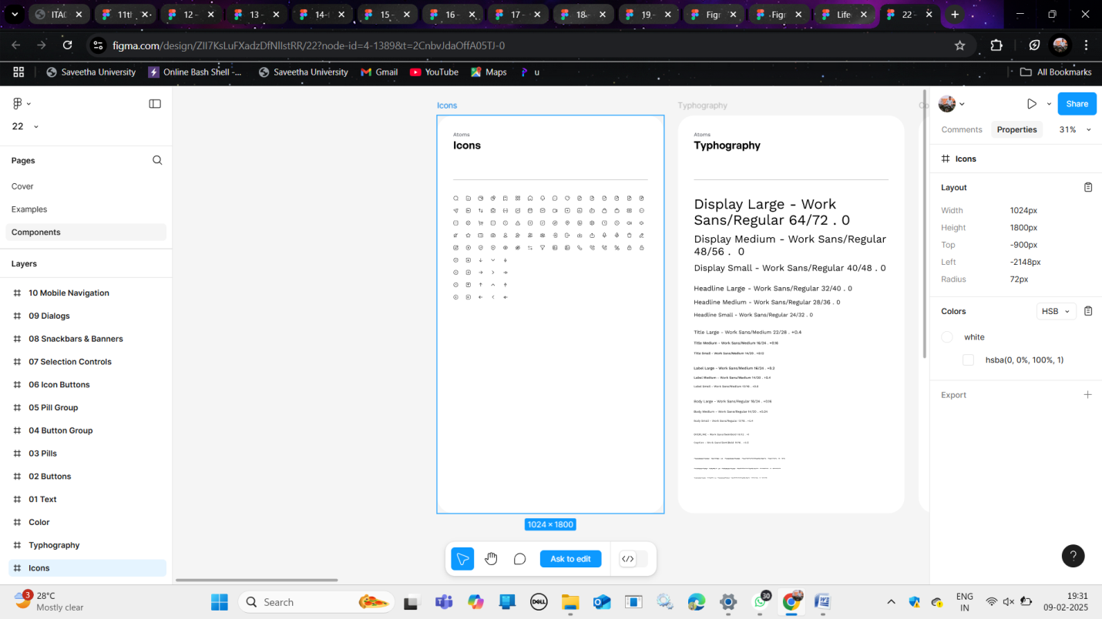

23 Develop a user interface prototype in Figma showcasing security measures for a mobile app. Emphasize the intuitive design for user personalization.
Link :: https://www.figma.com/design/LLz9vWRaRC417bvICBkjxD/23?node-id=1-2&t=CUMZaXi9wgsvM8Fd-0
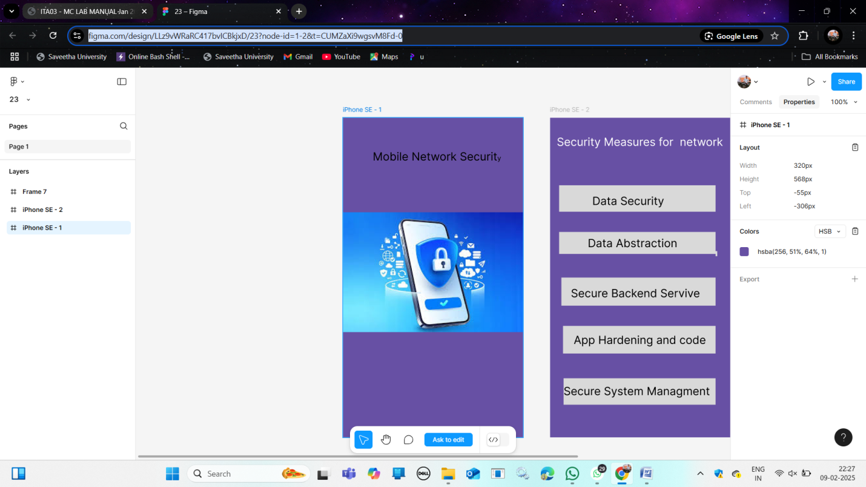
24 Use Figma to design a flowchart demonstrating the lifecycle of an Android Intent, including explicit and implicit intents.
Link ::: https://www.figma.com/design/UkqEdTM7kJ2aj1zTh4Xlnf/Lifecycle-of-an-android-intent?node-id=0-1&p=f&t=kkVxLmOFnn524RvG-0
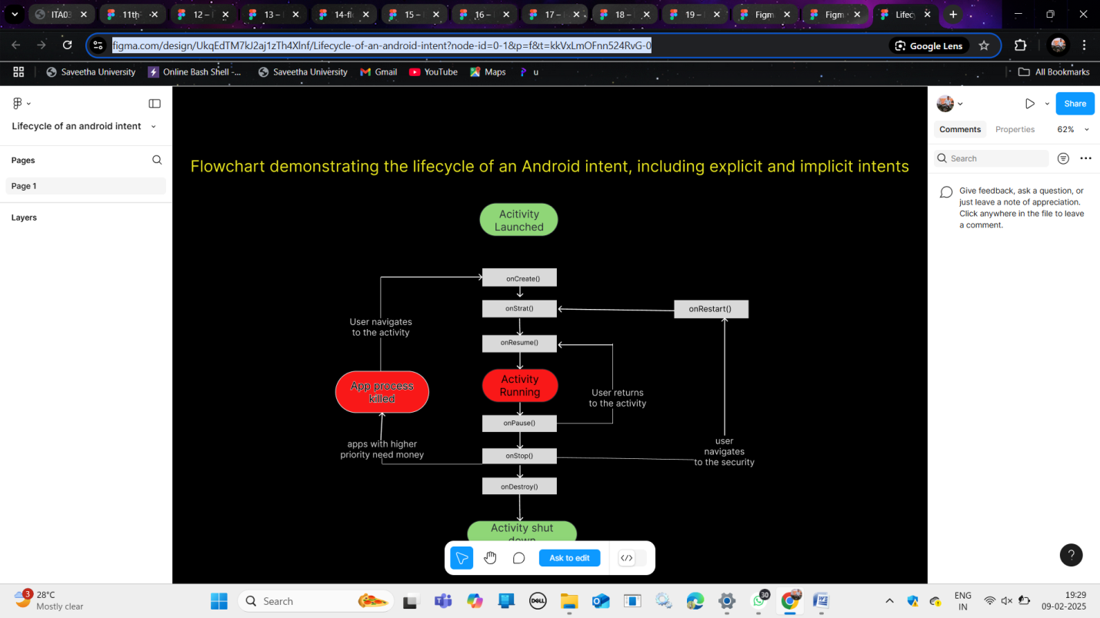

26 Design wireframes for a mobile app showcasing data replication techniques. Use Figma to demonstrate the synchronization process.
Link ::: https://www.figma.com/design/LlyJbJLHK1V2VtMaMUEwOE/Untitled?node-id=0-1&t=5i2enGD7lY8AAsRv-1
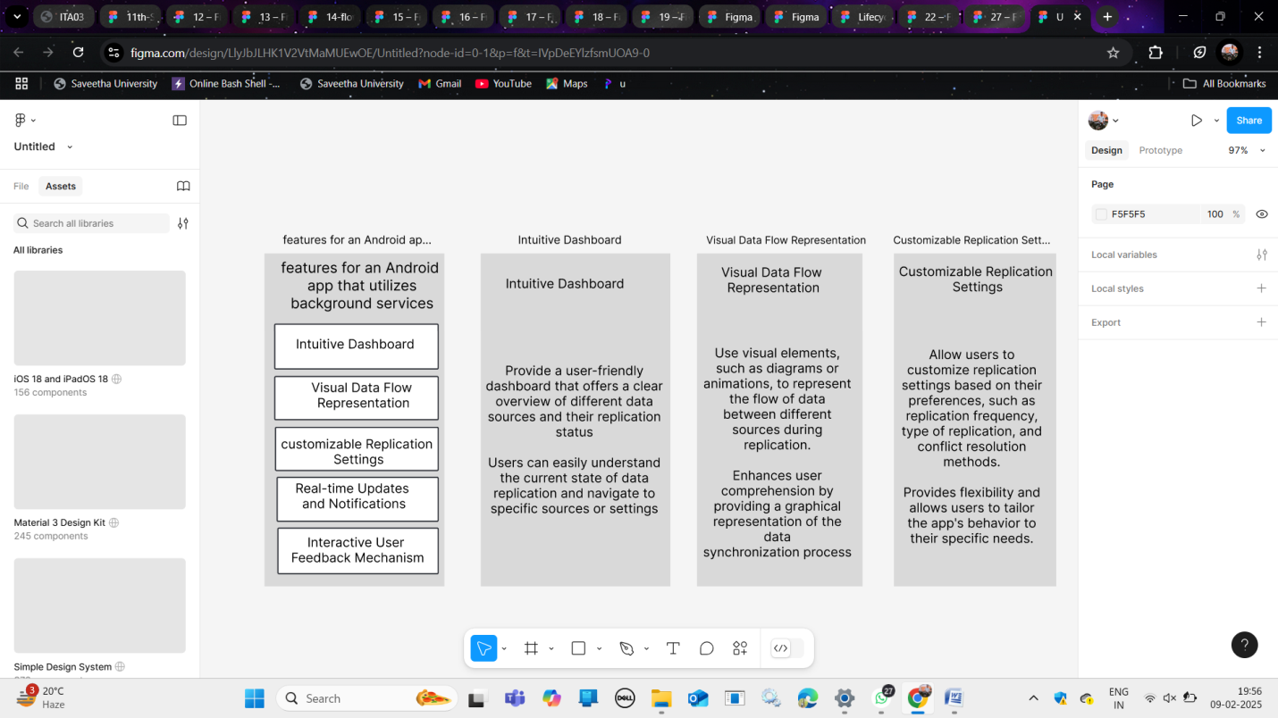

27 Use Figma to create an interactive presentation comparing the Core Video framework in iOS and the multimedia framework in Android.
Link ::: https://www.figma.com/design/Um9Dm5JxARMGgpBs9z3tbb/27?node-id=1-2&t=Vi7hQqdfuAhL8rXy-1
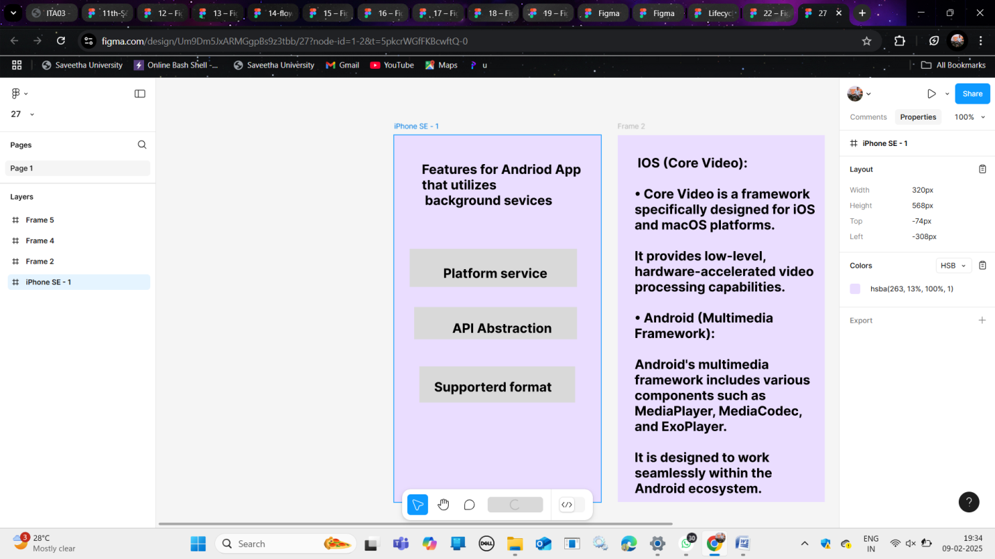

28 Design a wireframe in Figma for a multimedia-rich mobile app, incorporating elements from both Core Video and Core Media frameworks.
Link :: https://www.figma.com/design/AgNV0sZQJbNdX2QVETcxfa/Untitled?node-id=2-13&t=f6VRdupd9S8fhYjM-1
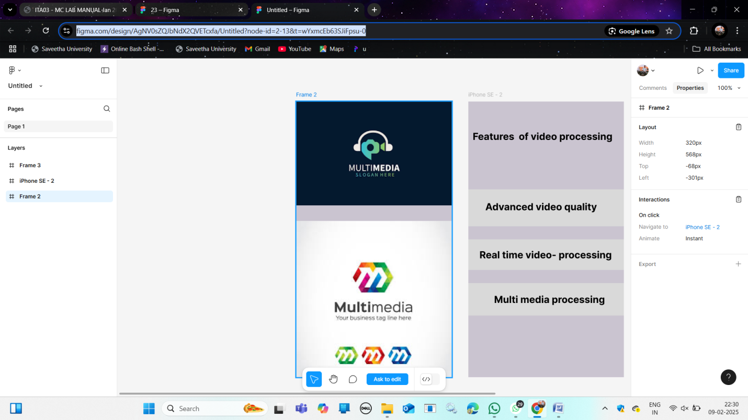

29 Create wireframes for a collaborative mobile app using Figma, showcasing the peer-to-peer interactions in real-time.
Link :::: https://www.figma.com/design/dSdYiz3D60vhSmdU2zMhNc/29?node-id=0-1&p=f&t=ZsEOuAYioIvJNpNK-0
